|  |
| --- |
| Imperial College London  Department of Mechanical Engineering  AME Project |
| Project Plan |
| Optimized Condensation for Energy Storage: Thermodynamics and Modeling |
| By: Omry Magen  Supervisor: Dr. Andrea Giusti  Submitted: 11.11.2022  Word count: 1154/1200 |



Contents

1. Introduction 1

2. Project objectives 2

3. Project plan 3

4. Personal timetable 4

References 6

List of Tables

Table 1: Project timetable (Gantt diagram) 3

Table 2: Personal weekly timetable: autumn term 4

Table 3: Personal weekly timetable: spring term 5

# Introduction

Condensation is a phenomenon in which a fluid changes it’s phase from gas to liquid in a process of giving up heat energy. In fact, it is a highly efficient way of removing heat from a fluid, due to the latent heat of the process which provides high heat transfer coefficients [1]. This occurrence can be observed in nature, but is also used today in technical processes such as in a steam turbine cycle, distillation, refrigeration etc. Understanding the physical details of this phenomenon can therefore be beneficial for optimization of such processes and even crucial for their design. Furthermore, efficiently implementing this in a Computational Fluid Dynamics (CFD) code could relinquish assumptions made on existing simulated flows and efficient codes may have industrial use [3].

The simulation of a multi-phase flow can be computationally demanding. Beside solving the mass, momentum and energy conservation equations, additional transport equations must be solved to account for mass and heat exchange between the phases in the vicinity of the interface [2]. Moreover, assuming additional species in the flow (e.g., humid air) can lead to non-practical simulations. This serves as motivation to conduct further investigation on models used today, potentially derive new models and to examine various means of optimization.

At first, the phenomenon will be studied from the thermodynamical perspective and general analytical models will be revised. Thereafter, the condensation of a single, suspended droplet will be considered for one species. For this, existing analytical evaporation models could be used, by adapting the equations and boundary conditions to describe the reverse process. Nevertheless, other existing models for condensation found in the literature will be examined. Then, other occurrences such as film and flat surface condensation will be derived and solved analytically, followed up with a parametric analysis for these models. This analysis will provide deeper understanding of these models and their sensitivity to parameters such as boundary conditions (B.C), initial conditions and generalization capabilities for other species. Finally, the chosen model will be implemented in OpenFOAM®, which will require adaptation of solver source code. The results of these simulations will be compared to other outcomes found in the literature.

# Project objectives

The project consists of multiple objectives which build upon each other. Therefore, the order in which they are listed is in line with the natural progression of the project and the way in which they will be pursued.

1. Achieving a fundamental understanding of the physical and thermodynamical process known as condensation and derive an appropriate model
2. Derive transport equations describing condensation under different field conditions
3. Implement an analytical approach to solving such transport equations
4. Execute a parametric analysis, testing boundary conditions and various species
5. CFD implementation of the model and comparison with other results
6. Simulate a realistic flow case using the created model

The objectives listed are the main aspirations of the project, however, this line of work offers high flexibility and adjustment of these in the course of the project is plausible, depending on the pace of accomplishment of the various stages. Consequently, introducing additional sophistication to the CFD aspect of the project can be relevant and pursued. Lastly, on a more general note, it is aspired that the project yield results beyond the scope of this year and that the knowledge acquired will serve as a valuable resource for future projects carried out in the department.

# Project plan

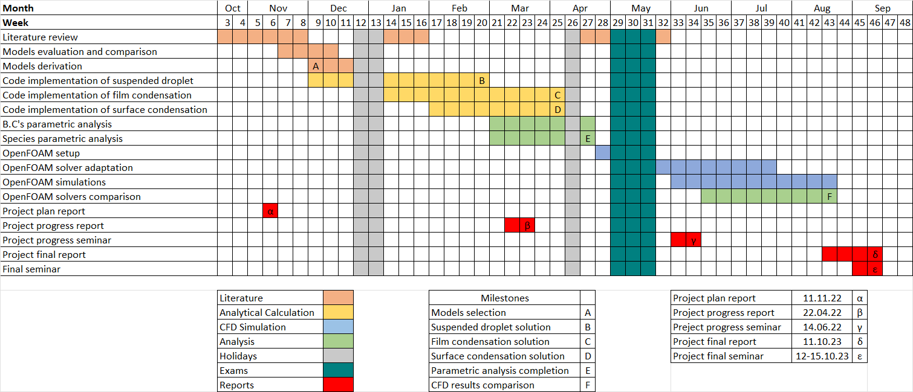

Table : Project timetable (Gantt diagram)

Table 1 introduces the Gantt diagram, an illustration of the expected project schedule. The diagram consists of four main categories of work: literature work, analytical calculations, CFD simulations and results analysis. While the main bulk of the work is composed of programming and implementing the selected model in various platforms, analyzing the performance of each of these will constitute the tone of future reports. Note, that exams outside of the marked examination period are not considered in the Gantt diagram as it is not expected to have sufficient influence on the project’s schedule. However, it is assumed that some changes will take place near the examination period (first three weeks of May), due to unknown dates at this moment.

# Personal timetable

A weekly routine will be allocated to working on the project throughout the year. My personal weekly timetable is illustrated below in Table 2 for the autumn term and Table 3 for the spring. Here, coloring differentiates between the activity type for various selected modules and the time allocated towards the project. Notice, that Wednesdays in the autumn term are fully dedicated towards project work including the weekly meeting with the supervisor.

|  |  |  |  |  |  |
| --- | --- | --- | --- | --- | --- |
| Time\Day | Mon | Tues | Wed | Thur | Fri |
| 9:00 |  | ES |  |  | IDP |
| 10:00 |  |  |  |  |
| 11:00 |  |  | P. Meeting | ML |
| 12:00 | ML |  |  |  |  |
| 13:00 |  |  |  |  |
| 14:00 | ES | AET |  |  |  |
| 15:00 |  |  |  |  |
| 16:00 | CFD |  |  |  |  |
| 17:00 |  |  |  |  |
| ML: Machine Leaning | ES: Energy Systems | CFD: Computational Fluid Dynamics | AET: Aircraft Engine Technology | IDP: Interfacing and Data Processing | Lecture |
| Tutorial |
| Project |

Table : Personal weekly timetable: autumn term

|  |  |  |  |  |  |
| --- | --- | --- | --- | --- | --- |
| Time\Day | Mon | Tues | Wed | Thur | Fri |
| 9:00 |  |  |  |  |  |
| 10:00 |  |  | ES |  |  |
| 11:00 |  |  | ES |  |  |
| 12:00 |  | CFD |  |  |  |
| 13:00 |  |  |  |  |
| 14:00 |  |  |  |  | CSFD |
| 15:00 |  | AET |  |  |
| 16:00 |  |  |  |
| 17:00 |  |  |  |  |  |
|  | ES: Energy Systems | CFD: Computational Fluid Dynamics | AET: Aircraft Engine Technology | CSFD: Combustion, safety and fire dynamics | Lecture |
| Tutorial |
| Project |

Table : Personal weekly timetable: spring term

The spring term allows more working time during the week which will be necessary due to the gradually increasing complexity of the project. The project meeting will be rescheduled towards the term’s starting date.

References

[1] Szijártó, R. 2015. *Condensation of steam in horizontal pipes - model development and validation,* ETH Zurich.

[2] Szijártó, R., Badillo, A., Ničeno, B., and Prasser, H.-M. 2017. Condensation models for the water–steam interface and the volume of fluid method. *International Journal of Multiphase Flow* 93, 63–70.

[3] Vuddagiri, S. R. and Eubank, P. T. 1998. Condensation of mixed vapors and thermodynamics. *AIChE J.* 44, 11, 2526–2541.